Name: Ubaid Bin Waris
Regno: 2212416
CNDC Lab task 3

HTTP post request using browser
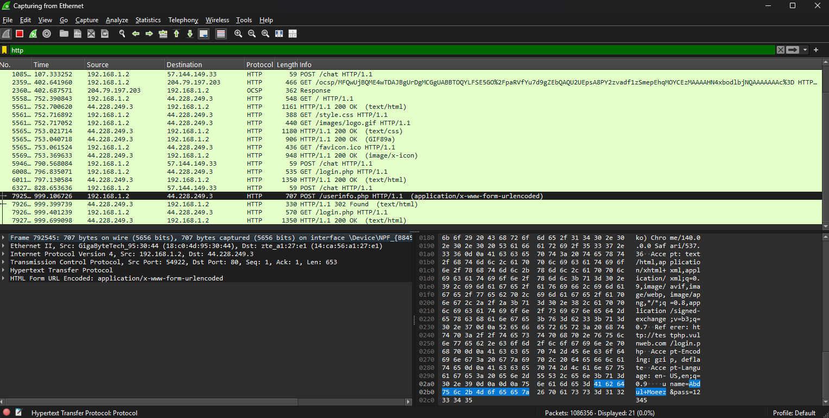

On Wireshark site
